10 Tips to Avoid the SUMMER SLUMP… the summer reading loss is real.
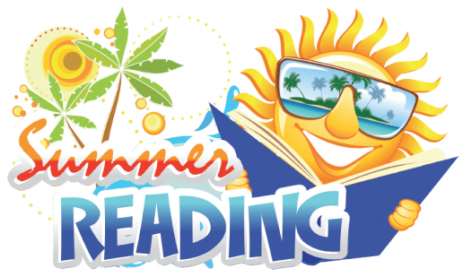

- Do it daily – turn off the TV and make time to read.
- Read aloud with your child.
- Discuss parts of the story.
- Read words you see to increase vocabulary. Read signs traveling, at the grocery store, in the newspaper, anywhere! And, talk, talk, and talk some more with a language rich vocabulary.
- Join the Summer Reading program at your public library.
- Take advantage of books found online – available 24/7.
- Keep a reading log to show progress.
- Be a good example – let your child see you reading.
- Encourage your child to write. Allow them to write the grocery list, a to-do list, a letter to grandma, a friend or find a pen pal.
- Just do it, keep reading and have a GREAT summer!

